# Installation of SQL Server 2019 Developer Edition

<https://www.microsoft.com/en-us/sql-server/sql-server-downloads>

# Feature Selection

Do ***not*** select all the features!

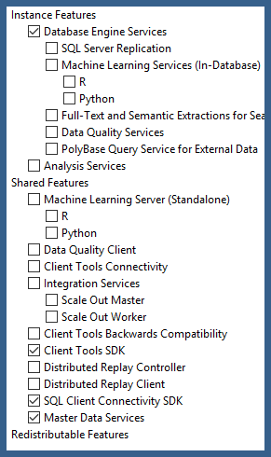

# Install the "Default Instance"

# Add yourself as an Administrator

Separately install the Microsoft SQL Server Management Studio.

<https://docs.microsoft.com/en-us/sql/ssms/download-sql-server-management-studio-ssms?view=sql-server-ver15>